Lisa R. Nelson  Home: +13160 24141 / Mobile: +1 9233 22430  Email: lisa@letsTEFL.com D.O.B: 9/12/1991  Address: Silver Spring, Maryland, United States.  • Teaching • Customer Service • Event Planning  I’m an American college graduate who majored in Social Sciences. I have a 120-hour TEFL certificate, and i’m currently looking for work teaching kindergarten level English in China. With my lively and hard-working personality i’m confident that i’ll adjust to life overseas in next to no time. | 

Work Experience

Store Cashier - Walmart  June 2016 - Present. Maryland, United States. | 
I’ve been working at Walmart since graduating, in order to build up funds for moving overseas. At this job I work as a cashier, serving customers and assisting with their inquiries.

Responsibilities:

- Serving customers
- Assisting with inquiries
- Providing special assistance to elderly customers
- Handling cash and till keys

Achievements:

- Passed health and safety training
- Received commendations for positive attitude

Reception Clerk - Safeway  March 2014 - April 2015. Maryland, United States. | 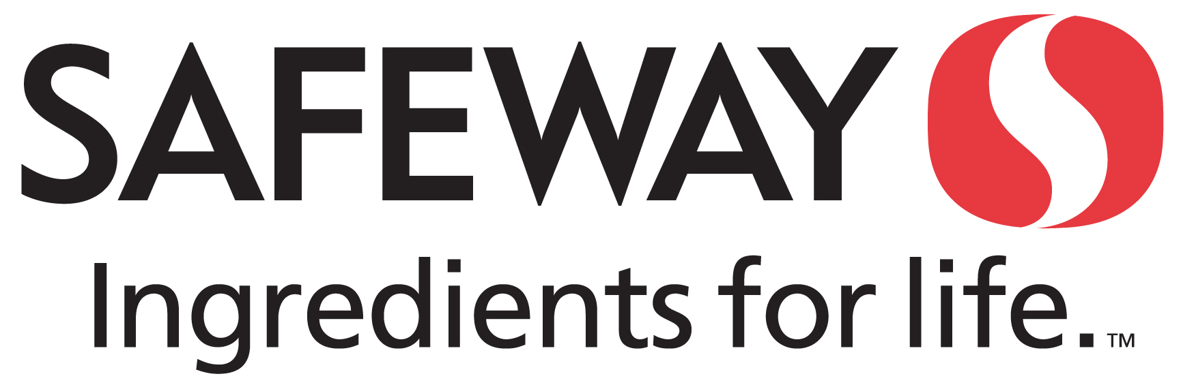
I worked at Safeway for one year whilst I was studying at College. I left this position during the final semesters of my degree so that I could concentrate fully on studying.

Responsibilities:

- Serving customers
- Assisting with inquiries
- Providing special assistance to elderly customers
- Handling cash and till keys

Achievements:

- Passed training for age-restricted sales

.

Education

 | University of Maryland  Sep 2012 - June 2016 | Bachelor's Degree:  Sociology Major GPA 3.6

Awards & Certifications

 | 120-Hour TEFL Certificate  Awarded Let’s TEFL Ltd.  I have gained an accredited 120-hour TEFL certificate. Through this course I studied different aspects of teaching skills, along with how to create lesson plans, teaching methodologies, classroom management techniques and how to test students.

Languages
- English: Native speaker, with strong writing skills.

- Spanish: Reasonable speaking, reading and writing ability.

Skills & Abilities
Personal:  • Friendly and approachable  • Great with kids  • Adapt well to new environments | Technical:  • Microsoft Office and Powerpoint  • Basic image and video editing  • Strong online research skills

Comments

I'm looking for employment in a school located within Beijing, China. I’d love to teach young learners as I feel they’d respond will to my bright and outgoing personality. Currently I am in the United States, but can arrive in China within 3-4 week’s notice.

To arrange interviews, or for any questions you may have, please contact me at lisa@letsTEFL.com.

